

C477 – Energy Efficiency and Energy Rating Calculations
Project Playbook

Prepared by
Bays Consulting Limited
Tel: 07788 643751, Email: sophie@baysconsulting.co.uk
Station View, Austen House, Units A-J, Guildford, Surrey, GU1 4AR
Registered in England & Wales 06995557 VAT No. 978 6752 45
www.baysconsulting.co.uk

2023

Executive Summary 1
Overview 2
Preprocessing 4

Executive Summary
This report outlines the steps taken to fill missing SAP scores in the dataset provided by ACE on the 15th September 2023. This draft dataset was made available to support the development of the code and creation of this playbook. A statistical approach was taken to output the prediction of an SAP score based solely on available EPC data. Such approach did not reverse engineer nor draw upon any proprietary data sets, such as the Parity Pathway data set.

Overview
The following assumptions, limitations and recommendations have been identified with the calculation of the SAP scores:
Assumptions
- The proportions in the raw EPC dataset are representative of the overall population of domestic dwellings (that is there is not a significant proportion of dwellings missing from the EPC data set).
- The categories used to calculate proportions are clearly defined and consistent across datasets (note this assumption was tested in the pre-processing aspect of the work).
- The mapping of proportions from one dataset to another is appropriate and meaningful.
- There are no systematic biases that would invalidate mapping proportions between the two available datasets.
- The proportions of the groupings are not affected by small sample sizes or other statistical issues.
Limitations
- There remains the potential for confounding factors that make the proportions inaccurate within the raw EPC dataset.
- The categorisation used may limit direct mapping between other datasets: the pre-processing has been developed for the datasets provided.
- Changes over time could alter proportions within the raw EPC data set.
- The calculated Energy Efficiency is a prediction and should not be taken as absolute.
- Only columns having no null values were used to avoid the inclusion of any bias in the calculation of the proportions.
Recommendations
- The proportions and distributions are refreshed on a regular basis.
- New data sources should be sought to allow for the SAP calculation (which forms part of the Energy Efficiency value) is calculated in its entirety.

Data
Two datasets were made available for use in this project:
- Raw EPC Data which is openly available online. This is not a clean data set but provided some SAP scores from which baseline distributions could be derived.
- Address Profiling data set was provided by ACE. This is a draft data set with some cleaning in place to which the predicted SAP scores were mapped.
Aim
The aim of the project is to use the raw EPC data to determine the Current Energy Efficiency and the Current Energy Rating for the properties in the address profiling dataset. For reference and completeness, the current:
- Energy Efficiency is a value between 1 and 100 that describes the efficiency of a property.
- Energy Rating is a letter, associated with a band of energy efficiency values, as shown below:
Energy Rating | Associated energy efficiency values
A | 92 and upwards
B | 81-91
C | 69-80
D | 55-68
E | 39-54
F | 21-38
G | 1-20
Table 1: Linkage between Energy Efficiency and Energy Rating
Potential Approaches
This section outlines the initial ideas and approaches that were considered. Not all of these approaches were taken forward to implementation; where these approaches were explored in greater depth, it became apparent that from an implementation or feasibility standpoint they would not add value to the output.
The three approaches considered were as follows:
- Approach 1: SAP score using proportions
- Approach 2: SAP calculation using SAP formula
- Approach 3: SAP score using a simplified worksheet
After having investigated the above three approaches in depth, it was determined to proceed with predicting the SAP score based on proportions. This decision was made based on the datasets available and robustness of the overall approach. The use of the SAP calculations (complete or reduced) was rejected due the extensive nature of additional data sets relating to the building required, as summarised below:
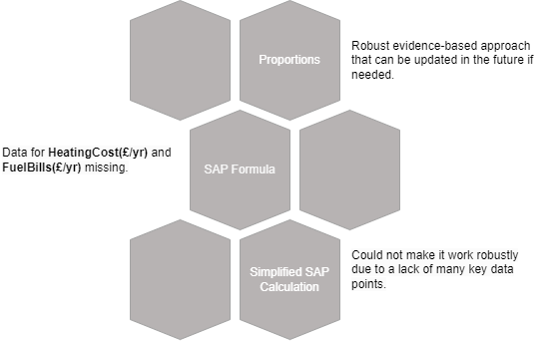
Figure 1: Potential Approaches
Selected Approach
Predicting the Current Energy Efficiency and the Current Energy Rating was achieved through a 4-stage process:
- Pre-processing of the available data to align the EPC and Address Profiling data.
- Calculation of the overall proportions of the SAP rating and SAP efficiency for each combination within the raw EPC dataset through clustering/grouping;
- Conversion of calculated proportions into probabilistic distributions;
- Mapping the predicted energy efficiency and energy ratings to dwellings within the Address Profiling data based on their respective combinations of features.

Preprocessing
To ensure the Address Profiling and raw EPC datasets matched, preprocessing was undertaken to ensure consistency (e.g., property type) with specific attention given to categorical features. Examples of pre-processing include:
- Multiple Glazing Type, contained values such as:
  - double glazing installed before 2002 in the raw EPC
  - DoubleGlazingBefore2002 in the Address Profiling data
- Main Fuel Type, had:
  - 38 unique values in the raw EPC data had to be aligned with the
  - 17 unique values in the Address Profiling data

Preparing Distributions
Getting EPC Proportions
The pre-processing was an important step to ensure the datasets could be grouped by the same variables, as required. Using a range of exploratory analysis techniques, the features used in the groupings to determine the proportions of the Current Energy Rating and the Current Energy Efficiency were:
- Property Type
- Multiple Glazing Type
- Floor Construction
- Wall Construction
- Roof Construction
- Built Form
- Main Fuel Type
An example of the output at this stage of the analysis are shown in Tables 2 and 3. Each combination has their own proportion for the SAP Rating (Table 2) and SAP Efficiency (Table 3) based on the raw EPC data.

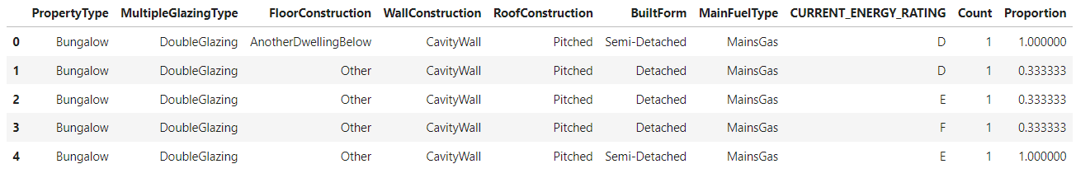
Table 2: Example of Proportions of Energy Rating in EPC Data

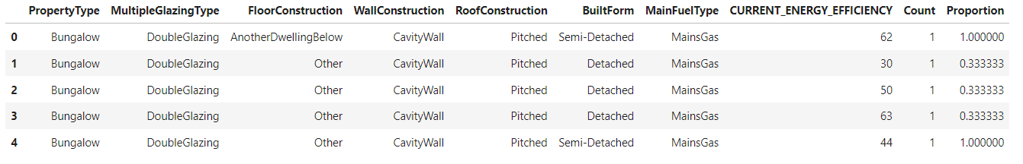
Table 3: Example of Proportions of Energy Efficiency in EPC Data

Converting EPC Proportions to Distributions
The proportions of SAP ratings for each of the combination of features from the raw EPC data were converted to probabilities of getting the SAP rating for each of the combination of features used.
The proportions of SAP efficiencies for each of the combination of features from the raw EPC data were grouped into their corresponding SAP Rating group (A-G). Within each SAP rating group, the proportions were converted to probabilistic distributions whereby all the distributions sum to 1.0 and are independent of each other.
For property in the Address Profiling dataset:
Step 1
Using the SAP Rating probabilities, the SAP rating for each property was generated based on their combination of features.
Step 2
Using the generated SAP ratings (from Step 1) and their corresponding probabilistic distributions from the SAP Efficiency distributions, the corresponding SAP efficiencies of the properties were generated.
Output
The final output of the predictions are Energy Rating and Energy Efficiency for each dwelling within the dataset. The results can be exported as a CSV file as needed or be retained as a Data Frame.

